This is your fundraising toolkit!

We developed this toolkit especially for you. It’s designed to help grassroots sporting clubs and organisations plan and execute successful tax deductible fundraising campaigns.
The toolkit takes a step-by-step approach — which we have tried and tested ourselves! It should contain all the information you need to develop, manage and promote your fundraising campaigns.
With the help of the toolkit, you should be able to:
- Decide on an achievable and meaningful target amount
- Set a date, timeframe and timeline of activities
- Create a story to share with potential donors and use for promotional purposes
- Decide on the platforms and audience to share your story with
- Ask for donations
- Thank your donors for their generous support
Along the way, if you have any questions or need further advice:
- Check out the Fundraising Resources on our website, asf.org.au
- Contact your ASF Sports Partnership Manager
- Call us on 02 6214 7868 or email us at info@asf.org.au
Happy fundraising!

So you’re keen to start fundraising.
Sometimes, fundraising can seem like a daunting task. The good news is, if you break it down into smaller phases and follow our toolkit, you’ll be underway in no time!
The most important thing to remember is that fundraising works best when your plan is based around your organisation’s capabilities. Be realistic about what your club or organisation can achieve. Don’t create a plan that requires you to do a whole bunch of new things.
Build a plan that you can manage and execute easily; one that plays to the strengths of your club. This may be through your club’s Facebook page and newsletters or at your weekly after-match functions. Remember, you can always do more next time!

What can you fundraise for?
You may be aware of this information from when you registered, but we want to make sure you’re really clear that you can promote tax deductible donations through F4S for ANYTHING that helps develop your club or organisation. This includes:
- Development and upgrades of facilities
- Purchasing or upgrading equipment
- Team travel
- Hosting of sporting events
- Junior development pathways and high-performance programs for senior players
- Participation programs
- Coaching and support staff costs
If your club or organisation wants to fundraise for something that’s not on this list, that’s fine! We welcome new ideas. Just be sure to include your idea in your online application, or contact your ASF Sports Partnership Manager to chat about your concept.

A quick overview of how fundraising works
Fundraising is all about generating funds by gathering voluntary contributions. These voluntary contributions can come from several key areas as highlighted in the diagram below.
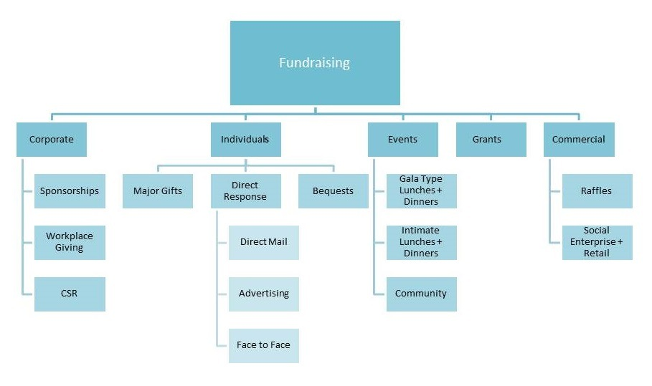Historically, sport has done a great job fundraising through a couple of key activities:
- Events
- Grants
- Raffles
- Retail – chocolate drives, etc
- Corporate sponsorship
As some of these more traditional methods begin to show less and less return, the key stream that we want to help you activate is tax deductible fundraising with individuals.
Our fundraising guide focuses on methods that you can use to drive fundraising through donations from individuals, be that for $10, $100, $1000 or $10,000.
As displayed in the diagram above, there are many ways to approach fundraising with individuals.
Major gifts are larger sums of money or donations of goods with significant value and the dollar value for what equals a major gift is totally dependant on what your club considers a major gift.
Direct response fundraising is anything that you do to directly ask people for money, resulting in an average donation for your club.
Bequests are monies donated to your club from the estate of a recently deceased individual.
There are some elements of the corporate stream that you can also explore for your fundraising. As mentioned, traditionally sports clubs and sports programs have benefitted from sponsorships but speaking to potential or current corporate partners about donating from their Corporate Social Responsibility (CSR) budget or getting involved in workplace giving can be beneficial.
There are many ways to activate fundraising within these streams and many of them are simpler than you would think. Our guide is designed to help you choose the right ones, and provide you with the confidence and planning to make fundraising a key and ongoing revenue stream.

Which fundraising activities work well for sporting clubs and organisations?
We have 30 years’ experience in sports fundraising. We’ve seen lots of different fundraising activities; some successful, some not so much. Below we’ve outlined a few that we hope will give you some inspiration for your planning. If you think back on all the times you’ve donated to a charity or cause, you’ll recognise some of these activities. We know these can deliver results and rely on minimal extra work to get started.

Memberships
A great time to collect donations for your fundraising project is during membership drives. You can request a voluntary donation from members for things like equipment purchases, representative team travel, community programs, and facility developments. Your club or organisation keeps the membership, and we process the tax deductible donations through F4S.
Initial considerations:
- Donations must be optional (i.e. members should be able to purchase their membership without making a donation)
- Make sure your members understand what their donations will be used for
- Allow for donations to be collected through online and printed membership forms
You can find out more on this and what you need to include on your website and donation forms on pages 15 and 16.

Processing donations
Your club or organisation forwards donated funds to us:
- Payment can be made by direct deposit or by cheque
- Frequency could be weekly during your busy registration period (to ensure members receive their receipts in a timely manner) and then monthly outside this period (for new members signing up mid-season)
Batch payments from your club or organisation will need to be accompanied by a spreadsheet with the following details for each donation:
- Date of transaction
- Donor’s full name
- Donor’s address
- Donor’s email address

Levels of recognition
One way to collect larger tax deductible donations from your more affluent supporters is to offer a ranking system. You may ask supporters to become silver members by donating $200. A gold member will donate $500, and a platinum member will donate $1,000. These figures can be set lower or higher, depending on the generosity of your target donors and your fundraising goal.
New donors could be announced at your next game, given a plaque to take home, and their names placed on the wall of your clubrooms.

Events
Events can be a great way to add value for your club supporters; you get a donation, they get to have a good time with friends and other members and supporters. Invite special guests to talk, such as former players and ex-coaches, to help put a face to your cause.

Ticket add-ons and pre-sales
Invite guests to a game, dinner, afternoon tea, breakfast, training session with the team—any event you can think of. Sell tickets in advance at a price that will cover your costs, then add an optional tax deductible donation to the ticket price (e.g. your club has dinner for $100 per head and you include a $50 optional donation request on the booking page or form remembering to specify the amount of the donation and what it’s for).
Your club or organisation keeps the money to cover event costs, and we process the tax deductible donations through F4S. Remember, the most successful way to fundraise through an event is to secure the funds before the event. As your guests will have already donated, it’s important to let them enjoy the event. Feel free to thank them for their contribution; just don’t ask for more money at the event.

Fundraising at the event
If you prefer to ask for donations at an event, you can use our online donation form (via tablet or mobile device) to collect donations instantly. You can also have printed forms on hand for your guests to complete at the event. Although distributing printed donation forms or collecting pledges can successfully raise funds, many guests may take that donation form home. They may have good intentions to fill in at a later time, only for it to be forgotten or accidentally discarded.

Emails and newsletters
Emails and printed newsletters sent to club members and supporters are an easy and efficient way to ask for donations. They allow you to tell your story and share images, while directing people to your website, social media pages, and your F4S project page (with a simple click of a mouse in the case of emails). Websites such as Mail Chimp or Campaign Monitor provide easy-to-use templates for electronic newsletters, and have the ability to personalise emails, such as addressing recipients by their first name. Printed newsletters can be handed out at games, training sessions, even on the street, if you do not have a database to send emails.

The personal touch
If you have the opportunity to collect a large donation from a club supporter (a person or a business), it’s best to meet with the potential donor face-to-face. Send the most senior person in your club or organisation i.e. your chairman, president, CEO, or prominent board member. This makes the potential donor feel valued, promotes confidentiality, and allows your organisation to really express its appreciation. You should aim to receive the donation or pledge on the day, rather than negotiating at a later date. Our online donation form (via tablet or mobile device) can help make this more comfortable.

It’s time to start your fundraising plan!
Now that you’ve been reminded about some types of fundraising that can work, you’re ready to start planning.
We’ve broken the planning process down into some key steps. We explain what you’ll need to do to complete each section and give you some examples to get your ideas flowing. At the back of this guide, you’ll also find some templates that you’ll need to complete.
And remember, if you get stuck along the way, get in touch with us. We’re here to help!

Part 1: Developing your fundraising idea

What are we raising funds for?
The first step of any fundraising campaign is to decide exactly what you’re raising funds for. Make it a clear goal that is:

Specific
Exactly what are you raising funds for? Is it for new clubrooms, uniforms, travel to a carnival, whatever? What’s the dollar amount you need to raise? Be as specific as possible.

Measurable
How are you going to measure and monitor whether or not your goal has been met?

Attainable
A goal should be challenging, but not unrealistic. What is the size and scope of your project? Does your club have the people, time and resources available to raise the funds? It’s always better to underestimate than over estimate.

Relevant
How does the goal tie into your key responsibilities? How will your goal advance your club or organisation? Will it attract new and better players? Or provide better amenities for spectators?

Time Bound
Even if you don’t have a hard deadline for your project, set an end date for your goal. This allows for better scheduling and increases the motivation of everybody involved.
Create your own fundraising goal in the template on page 21. Some examples of a fundraising goal are:
“We are looking to raise $2000 by June 30 to purchase new netball bibs and balls. This will enable us to expand our competition and include an additional 20 teams in our Summer Social Competition which starts on 1 November.”
“Our school is fundraising to purchase five new quads to expand our rowing program. This will help us to get more kids involved in the program. Our target is to raise $20,000 by the end of the year.
“We are trying to reach $5000 in funds raised by the end of the season. This means we can pay for the travel and accommodation for a group of 10 underprivileged kids from our football club to go the state championships.”

Who’s your target audience?
Your target audience will be the people you intend to ask for donations. If you can define these people (by where they live or how much they earn or their years of membership, for example), you’ll be able to target your fundraising ideas more successfully.
Once you’ve defined your target audience, you can decide the best ways to reach them. If you have a broad target audience, you may choose to use social media. If you have a small and specific audience, handing out flyers at a BBQ or a game may be more appropriate.
Define your target audience using the Part 2 template. An example of a broader target audience might be “people who live in the local area and are interested in AFL”. A more specific target audience might be something like “the parents and guardians of the players at West Belconnen Lions”.

Write your fundraising story
Your story should get potential donors (your target audience) excited and motivated about your fundraising project. However, don’t presume your audience knows everything about your organisation or why you’re trying to raise funds. In fact, you should write your story as though you’re talking to someone who has never heard about your organisation or its fundraising goal.
Inform people of why, how and when they should donate. The story is the bedrock of any campaign. It’s central to all fundraising activity. You must take the time needed to get it right.
Your story should answer the following questions:
- Why does your club need this money?
- Who and how many people will benefit?
- When do you need it?
An engaging and successful story will have four key ingredients:

Need
This is the starting point for any fundraising story. What are you trying to achieve through your fundraising program? Exactly how much money do you need to raise?

Cause
What EXACTLY are you raising money for? This isn’t as simple as saying: “We’re raising money for our U14 team travel fund”. You need to be more specific and say something like “We’re raising $15,000 for our U14 team to travel to the state titles and represent our club against the best in the state”.

Impact
You need to share the emotion of your story. An impact outlines EXACTLY who will benefit from the donation. You need to describe the changes that will be seen through the donation and the impact it will have. An example would be: “We’re raising $15,000 for our U14 team to travel to the state titles and represent our club against the best in the state. This is a life-changing opportunity for our young players. It’s one never had by any team from our club before. And it will only be made possible through the kind support of people like you”.

Ask
Don’t be afraid to ask. No fundraising program has ever been successful without asking. Your request will be far more effective if it’s really specific and lines up with the emotion of your story. An example might be: “A donation of just $10 provides a football to a child who has never owned one before. Can you help?”. Or “$25 will pay for the tournament uniform for one of our less fortunate players. Will you assist?”. Make sure it’s obvious why your target audience should care. Also remember that you need to let the donor know how they can make their donation. And have a sense of urgency. You want them to know that you need them to donate now.
Some great examples of fundraising stories can be found on our website asf.org.au. Go to the ‘Our Projects’ page and simply click on the ‘View Project’ or ‘More Info’ tab on any of the projects.

Part 2: Marketing and promoting your fundraiser
Now that you’ve worked out what you are saying and who you are saying it to, the next step is to work our how you are going to deliver your story. This is about finding the best ways to make people aware of your fundraising project.

Timeline for promoting your fundraiser
By preparing a timeline, you can clearly outline your promotional activities to specific dates, and give your players, supporters, committee members and others something to follow. You can also use the timelines to invite new ideas or open up discussion about things that need to be worked through. Each section of the plan involves using the story that you will have prepared earlier.

Phase 1: Initial storytelling
Date | 1-2 months before your fundraising event or the deadline for the funds.
Messaging | The broad story. This is introducing people to your organisation and your fundraising story, or your cause.
What you need to prepare | Images of the people and places your cause will benefit: people from your club, team, school or organisation; the building your funds will benefit; anything that portrays what you’re raising funds for.  Facts and figures on the number of people your cause will impact, e.g. “This will support 64 basketball players travel to the national titles.”  A general overview of what you’re fundraising for. Write a version in 200 words and a version in 30-50 words. This shouldn’t include a request for donations (that part comes next).
Phase 2: The ask
Date | 2-4 weeks before your fundraising event or the deadline for the funds.
Messaging | Provide options of specific amounts, e.g. “$15 will pay for a bus ticket for one team member to travel to the national titles. $50 will pay for a uniform for one of our less fortunate players.”  Tell the donor how much you are asking for. Tell him or her where, when and how they should give you the money. Specify whether this is at an event on a certain event, or share your ASF online donation page and ask for donations by a certain date.
To prepare | Images as above  Facts and figures as above  Two new versions (200 words and 30-50 words) of your story. This time include a specific request (this could be for specific amounts; $5, $20 or $100)  Start thinking about holding a thank-you event, or preparing letters/certificates/plaques for your donors.
Phase 3:Thanking Donors
Date | 1-2 weeks after your project comes to a close and all funds have been received.
Messaging | Thank your donor for their donation in a sincere way. Be sure to include where their money will be spent. Tell donors that their support will help you make a meaningful change to people involved in your club or organisation.
What you need to prepare | A new round of images, if possible showing the impact of the donation  Facts and figures about how many donations you received, and how you received them  Two new versions (200 words and 30-50 words) of your story, including a thank-you with specific figures  Any event or gift that you may use to show your appreciation (see page 14 for more details).
Phase 4: Impact
Date | 1-2 months after your project comes to a close and all funds have been received.
Messaging | Once your fundraising is complete and the money is being spent, let donors know exactly how much money was raised. Remind them what the money is going to be spent on, and when the project will be complete. Reiterate the impact their donations have made or will make.
What you need to prepare | A new round of images, if possible showing the impact of the donation  Facts and figures about what you are doing with the donations, including a timeline of when the project will be complete  Two new versions (200 words and 30-50 words) of your story to update your donors. This should include as much of the following as possible:  An outline of your entire fundraising experience  How much support you received  How you went about raising the funds  The exact amount of funds you received  How many people benefitted from the cause
Phase 5: Outcome
Date | After your project is complete.
Messaging | Share the outcomes of your project and the number of people who have benefitted. Talk about the emotional aspects of your fundraising story; unique experiences, lives changed, or benefits to the community. And remember to thank your donors for making the project possible.
What you need to prepare | Images of the completed project, showing the difference the donations have made. ‘Before & After’ shots and smiling faces always have a big impact.  Two new versions (200 words and 30-50 words) of your story, highlighting how successful the project was, the practical and emotional benefits to your club or organisation, and a MASSIVE thank-you to all your donors.

Why you need two versions of your story each time
To share the story of your fundraising at each phase of the project, it needs to be in two different lengths to suit where you intend to tell it.
Your 200-word versions can be used for things like flyers, emails (electronic newsletters), printed newsletters, your website, free editorials in community newspapers, speeches at events, and places where you are not restricted for time or space.
Your 30–50 word versions can be used for social media, quick match-day announcements, and anywhere you only have a small amount of space or time to talk about your fundraising. When writing these shorter versions, imagine you’ve just met someone in a lift and only have a very short time to sum up what your fundraising is for.
Creating so many versions may seem like a lot of writing, but it’s really quite easy. Simply prepare one of each length as your basic message, then make slight changes as you work through the phases.

Take photos for your promotional activities
As you’re preparing your story versions at each phase, you should also take photos to use for your promotional activities. Six to ten photos should be sufficient. The key is to make sure they reflect your club or organisation and give people a sense of who you’re trying to help or what you’re trying to achieve. For larger projects, such as building improvements, these photos can also make a great montage for your website or clubrooms once your project is complete.
It’s very important when using these photos to be wary of large file sizes. If your images are too large, they can slow down the delivery of emails and effect how fast websites load. They can also make it difficult to create flyers and printed materials. If you need help resizing images, you can find a helpful guide on our website at https://asf.org.au/fundraising-resources/marketing-tips-and-tricks/how-to-crop-images-using-paint/

Logos
Australia Sports Foundation logos are available through via the partnership portal. Our logos should be placed on any of your marketing and promotions related to your tax deductible fundraising.

Marketing and promotional activities
Below are some of the most commonly used tools to promote your tax deductible fundraising. If you’re unsure about whether or not you should pursue other marketing or promotional ideas, just give us a call on 02 6214 7868 or email us at info@asf.org.au – we’re here to help!
Your club or organisation website
If your club or organisation has its own website, it’s vital that you include links to your fundraising project and/or donation pages on asf.org.au. It’s a good idea to include links on as many pages of your website as you can. You could also ask your major sponsors if they would be kind enough to include links to your fundraiser on their business websites – but be careful not to stretch the friendship!
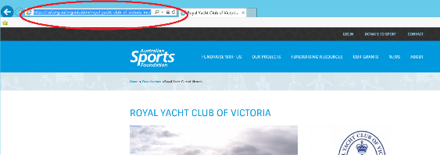
Information for the person who runs your website and/or social media:
How to post a link to your ASF project page/donation form:
- Head to your project page on asf.org.au
- Copy the hyperlink at the top of the page
- Post the link into the hyperlink field

We’ve also created several donation buttons that can be found on our F4S partnership interface. All the instructions for using these buttons are included on the interface.

Emails: Mail Chimp or Campaign Monitor
Mail Chimp and Campaign Monitor are two web-based platforms for sending bulk emails. They’re both affordable and easy to use. They enable you to store lists of contacts, send stylish and trackable emails, and manage your communications easily.
Using one of these platforms, you can:
- Create your email with simple, good-looking templates
- Add your branding, logo and images
- Add personalisation such as first name and last name (people are more likely to respond to a personalised message than a generic email).
- Get insights into how your emails are performing. See how your audience is engaging with your emails, which donation requests are most effective, and more.
You should include your full story (see page 10) and a link to your ASF project donation page. And remember to make a specific donation request (see page 9).

Membership or registration add-ons
Your club or organisation probably already has a way of collecting membership dues or registration fees. Adding a tax deductible donation to these is simple and requires little work. You keep the membership or registration amounts, and simply send the donations to us in one bulk payment, with a breakdown of those who donated. Simple! We have provided an excel spreadsheet ready to fill out, to make sure all correct information is collected. Simply fill in this spreadsheet and email to donations@asf.org.au
Below are the different ways you can promote tax deductible donations through your existing activities:

Online
After setting out the membership fee/s, you could include a line that simply says:
“Tax deductible donation for <<project name>> $_____”
The donor can either type in an amount of their choosing, you can give them a few amount options or prepopulate a specific amount (remembering that it’s voluntary so they can opt not to donate)
To help ensure your members understand what you are fundraising for, you could include a url link (either to an information page on your website or your ASF fundraising page) or a pop-up box with a brief “story” about your fundraising need
The donor would need to check a mandatory box agreeing to the ASF’s terms & conditions (https://asf.org.au/about/terms-conditions/) and privacy policy (https://asf.org.au/about/privacy-policy/). If an amount is entered in the donation section, the member should not be able to proceed without checking this box.
The ASF logo should be included in the donation section of your membership form.
Members make one payment to your organisation, which will include their membership fee and donation (if making one).
Your website administrator should be able to provide you with a list of all members who have opted to make a donation (see below for processing tips).

Offline
After setting out the membership fee/s, you could include a line that simply says:
“Tax deductible donation for <<project name>> $_____”
The donor can either write in an amount of their choosing or you can give them a few amount options.
The following donor declaration should be included (and must be ticked by member):
“I would like my gift to benefit the <<your project/organisation name>> and I understand that my donation is made unconditionally to the Australian Sports Foundation. By making this donation, I accept the ASF’s Privacy Policy and Terms and Conditions”
Our logo should be included somewhere on your membership form.
Members make one payment to your organisation, which will include their membership fee and tax deductible donation (which must be optional).

Flyer template
We have a terrific template for flyers to promote your tax deductible fundraisers. Simply go to https://asf.org.au/flyer-template/ to get the template and instructions on how to use it.
All you need to do is fill in the blanks and you’ll have a meaningful and motivating story with a clear and direct pitch to your potential donors. You can use this to hand out on game days, at events, and around your community.

Social media
If your club or organisation is active on social media – and you really should be – it’s a brilliant tool for your fundraising campaign.
Social media sites are fantastic places to use your short and punchy fundraising stories (the 30-50 word versions) with images that engage your audience. You can also easily link to your ASF project and donation pages when posting on Facebook, Twitter, Instagram, LinkedIn and other social media sites.

Information for the person who runs your website and/or social media:

How to post a link on social media to your ASF project page/donation form
- Head to your project page on asf.org.au
- Copy the hyperlink at the top of the page
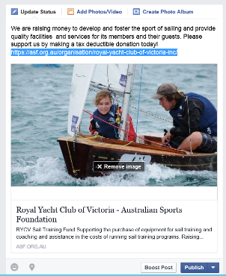
- Post the link into the status bar of Facebook. A photo or an option to ‘upload an image’ will appear; choose an image that will draw attention and motivate people to donate.
Helpful hint: Once you’ve pasted the hyperlink into the status bar, you can actually delete the hyperlink, but the link Facebook has created will not disappear.
You can follow this procedure to link to either your ASF project page or your ASF donation page, depending on where you’d like to send people.

Information for the person who runs your website and/or social media:

How to drive more people from your website to your social media
You probably have a link to your website on your social media, but do you have links to your social media on your website? Adding social media buttons to your website makes it quick and easy for website visitors to find and engage in your social media.
All the instructions below are for desktop and PC sites, and may not apply to device-friendly versions of sites.
Instagram
Jump on the website https://instagram.com/accounts/badges/ > select your badge size > copy the code that will appear > paste the code wherever you would like the badge to appear on your website.

Facebook
Jump on the website https://www.facebook.com/badges/page/ > you can edit the badge, located on the right hand side of the page > when asked where you will share the badge, select 'other' > copy and paste the code wherever you would like the badge to appear on your website.

Twitter
Head to this website https://about.twitter.com/resources/buttons > select your desired badge > fill in 'button options' that will appear > copy and paste the code wherever you would like the badge to appear on your website.

LinkedIn
Start at your profile > Edit Profile, then click on "Edit" next to your public profile URL (at the bottom of the grey box), and "Create a profile badge" on the right-hand side under Profile Badges > copy and paste the code wherever you would like the badge to appear on your website.
Now that you understand a bit more about the options for promoting your tax deductible fundraising, you’re ready to complete the templates in the final section of this toolkit.
Once you’ve completed the templates and prepared your promotional plan, images, story, and any other requirements, you’re ready to start raising funds!

Part 3: Oh, and one more really important thing…
Thanking your donors – this part is really important!
Properly thanking your donors can be vital to the fabric of your club or organisation, and can help drive successful fundraising programs in the future.
Here are some key statistics that illustrate why it’s important to show your donors that you appreciate them:
- Simply by thanking a donor, you have a 50% better chance of receiving another donation from him or her the next time you ask.
- If you inform your donors about how their money was spent, how much it was appreciated, and the practical and emotional impact the donations had, future donations have been seen to increase by as much as 40%.
Use the table below to help compare the size and impact of the donation with how big your thank-you should be to each donor.

The request | The donor return
What was the donor asked to do?  What was the dollar amount?  Was this donation process a low, medium or high level of involvement? | How will you keep the donor engaged once they’ve donated?  How will you update them on the project and what can you ‘give’ them in return?  A small, low-involvement donation may require a thank-you email. A large donation with a big impact may require a free barbecue and/or a plaque awarded.

Thank you dos
As you’d know, the best thank-you always feels friendly, warm, personal and genuine. Your thank-you message is a way to build relationships. Keep the writing informal. Forget about starting your letters with “On behalf of” or “Thank you for” and use a more creative and personal opening. Try something like “You’ve made my day” or “Our young players are rapt” on one line by itself. Then launch straight into the success and emotional impact of your fundraising project.
Include photos: Let the donor see the smiling faces of the people they’ve made happy, or photos that demonstrate the impact on facilities they’ve helped improve.
If you have repeat donors over the years, start to have different people deliver the thank-you. Instead of your president or CEO, you might get your club captain or senior coach to say thank you.
Make sure the donor knows how his or her donation was used. Donors like to know that the money they give makes a tangible difference to the club or organisation. Give breakdowns of numbers where applicable. Be specific. Give examples. Tell stories.

Thank you don’ts
Never ask for another donation as part of your thank-you message. This communication is all about the donor and the specific fundraising project they contributed to.

Thank you ideas

Emails or letters
For all donations, a letter or email thank-you requires little cost and effort. By using one of the websites for sending emails, which were mentioned earlier in this toolkit, you can create a beautiful thank-you message. You can also track how your donors respond when receiving your emails.
For a smaller number of donors, or for your older supporters, personalised letters sent to their homes can be a nice touch. Include images of the project or the people who benefitted from their donation.

Thank you events
An event can be a great way to say thank you to your more generous donors. This event could be as simple as an afternoon tea, a cocktail party, a dinner, or a game dedicated to the donors (where their names are announced).

Public recognition
If your club or organisation has a newsletter, you may wish to name the donors in an honor roll. You could also have a plaque, with the names of donors listed, on the wall of your clubhouse. Be careful about mentioning the dollar amounts that people have donated. Some people, especially those making larger donations, can be sensitive about this sort of information being public knowledge.

Certificates and plaques
Give your donors something to take home. This may be a certificate, a medal or a plaque.

Regular updates
Using emails or letters, keep your donors updated regularly throughout the year. Let them know how your organisation is progressing thanks to their donation. For example, you might email a donor and say: “We’ve already won 10 games this season! We think our players have been given a big boost by the new uniforms you helped to pay for. So, thanks again!”

And that’s how you fundraise!

Remember, successful fundraising includes:

Ask
If you don’t ask, you don’t get. It’s the golden rule of fundraising. Few donors go out of their way to find charities or causes to give their money to. While it may sometimes seem uncomfortable to ask, it’s essential!

Show the impact
What will my donation achieve? Donors want to know that their contribution will make a difference. The higher the donation, the greater the desire to know exactly where it’s going.

Deliver on promises
Did you do what you said you’d do? You must prove that the donations made a difference; that your club or organisation has been improved or is making progress; and that a group of people’s lives are better as a result.

Build relationships
Sustainable fundraising is about establishing and nurturing relationships between donors and the sports they love. Make sure your relationship with the donor is about more than just the money he or she has contributed. They need to feel part of your club or organisation. Let them share in the successes of your club or organisation, both on and off the playing field, and introduce them to other like-minded supporters.
Remember, we’re here to help! If you have any questions or would like some guidance, please feel free to call us on 02 6214 7868, email us at info@asf.org.au or contact your ASF Sports Partnership Manager.

Templates

PART 1
FUNDRAISING – Refer pages 8–10

Our fundraising goal is …
Complete this section.

Our target audience
Complete this section

Fundraising Story

PART 2

MARKETING AND PROMOTIONS – Refer pages 11-18

This template indicates some activities you might choose to undertake to promote your fundraising. If you plan to undertake a different activity, simply add it to the document. The best way to list activities is in date order within each section.

YOUR ORGANISATION NAME
 | AUDIENCE | WHO IS RESPONSIBLE | DETAILS | DEADLINE
BASIC MARKETING AND PROMOTION ELEMENTS
COPY
KEY IMAGES
DIRECT MARKETING
EMAIL
COLLATE LISTS FOR EMAILS
DEVELOP EMAIL
FINAL EMAIL READY FOR SEND
POSTERS AND FLYERS
SELECT/PREPARE COPY AND IMAGES FOR EXECUTIONS
CREATIVE DEVELOPMENT OF COLLATERAL
FINAL COLLATERAL FOR PRINTING
PRINTED AND DELIVERED
DISTRIBUTION
EVENT ACTIVATION - AWARDS? Event?
SCOPE ONLINE TICKET PURCHASE WITH DONATION ADD-ON CAPABILITY
SCOPE COPY AND IMAGERY ELEMENTS TO INCLUDE IN INVITATION (IF REQUIRED)
DEVELOP ONLINE TICKET PURCHASE WITH DONATION
DEVELOP HARD-COPY DONATION FORM FOR USE AT EVENT
CONTENT FOR INVITAITONS FINALISED
INVITATIONS FINALISED
INVITATIONS PRINTED/EMAILED
INVITATIONS SENT
BRIEF MC
PRINT FINAL COLLATERAL FOR EVENT
SOCIAL MEDIA
CREATE KEY SOCIAL MEDIA POSTS FOR VARIETY OF CHANNELS BASED ON KEY MESSAGES
DEVELOP HASHTAGS TO SUPPORT CAMPAIGN CONVERSATION
ACTIVATE SOCIAL COMMUNITIES
WEB
WEB PAGE CONTENT SCOPED - COPY, IMAGES AND VIDEO REQUIREMENTS
MAKE WEB PAGE LIVE
HOMEPAGE CLICK THROUGH LIVE
ASF WEBPAGE
ASF DONATION PAGE
SCOPE DONATION ADD-ON
DEVELOP DONATION ADD-ON
FINALISE DONATION ADD-ON
DONATION ADD-ON LIVE

Our sharable story
200 words
30–50 words

Membership add-on’s text
“I would like my gift to benefit the <<your project/organisation name>> and I understand that my donation is made unconditionally to the Australian Sports Foundation. By making this donation, I accept the ASF’s Privacy Policy and Terms and Conditions”

Event flyer or invitation template
Join us, <insert organisation name>,
in changing the future of our club and help celebrate the launch of <insert project name>.
<project name>, partnered with the Australian Sports Foundation, is raising funds to
<a few lines as to what you are raising funds for>

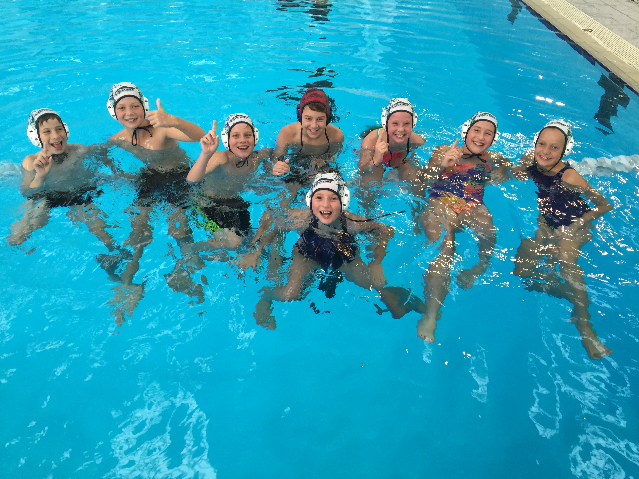

To celebrate the launch, we are hosting a <name of event e.g. gala dinner>
Where:
When:
includes: e.g. silent auction, raffles, open bar, karaoke
Attire:
RSVP by:
Tickets can be purchased through <way of purchase>.
<ask for funds: $50 will purchase a new soccer ball for our afterschool club and allow 20 more boys to participate>, so please involve yourself generously on the night.
Thank you for your ongoing support and we look forward to seeing you there.

Fundraising letter template
Dear <recipient’s name>,
We need your support to improve our club!
<Share your story here, this is the story you wrote in Part 3>

To achieve this, and give our club the support it needs, we must raise <target amount> by <planned end date>. This might sound like a lot, but if each of our <number of club members> can donate <particular donation amount> we will succeed.
Any donation, whatever size, will make a difference and each donation over $2 is tax deductible through the Australian Sports Foundation. Donations can be made by going online to asf.org.au and searching for <project name>, or by filling out the manual donation form included, and send to <organisation address>.
Thank you for your ongoing support.
Please contact us if you have any questions.
<Name of sender>
<Contact details>

Notes

Use this space to make notes about idea as you read!

