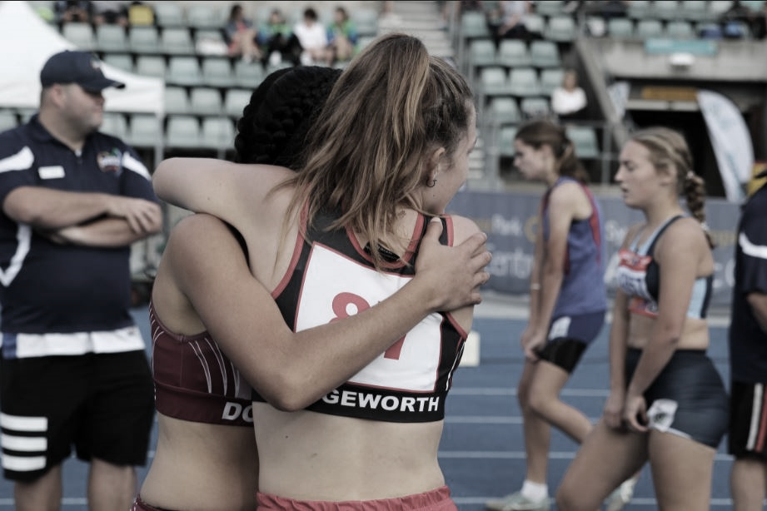
Harris Park Little Athletics

ANNUAL REPORT

2020
Email: [Email Here]  Website: [Website Here] | Tel: [Telephone Here]  Address: [Address Here]
TABLE OF CONTENTS
President’s Report 3
Secretary’s SUMMARY 4
Treasurer’s Report 5
Centre Financial Reports 6
Statement of Accumulated Funds 7
Audit Report 8
Registrar’s Report 9
Tiny Tots Report 11

President’s Report
Another season of Little Athletics has been and gone, the 28th season for our centre and one that once again has benefitted from the hard work of our outstanding committee members and volunteers and has been enjoyed by many a little athlete. As usual, the season was over in a flash and now it is time to take stock and begin the process of planning for next year.

Our centre experienced another successful season in 2019-2020 due to the efforts of many people. Firstly, I would like to extend my personal congratulations and thanks to the members of the committee. You have all added so much value to this centre and your commitment and passion helped to get the job done. Secondly, I wish to thank the age managers for looking after the children during the year at their various events and championships. Last but not least, I want to thank all those parents who have helped in a range of ways, whether it was pitching in to rake the pit, supporting carnival days, retrieving shot puts, or helping to run the canteen. Here is where I include the usual pitch for more parents to join our community of volunteers and share the load in making our centre the success that it is and the experiences for our children positive ones. There are a range of volunteer responsibilities that vary in time commitment – if you are able to get involved, even in a small way, please connect with one of our committee members to discuss options.

I would also like to draw special attention to our sponsor, Harris Park Motors, who without their support the investment made into new equipment and supplies for our centre would not have been possible. We are very grateful for their on-going support and Harris Park Little Athletics looks forward to working closely together in the future.

After experiencing such a great season, it can be difficult to only mention a few highlights, however, one of the significant moments included 20 of our athletes qualifying for the State Championships, which was a centre record! Well done to all involved in this achievement. This year also saw the introduction of senior’s competition on Friday evenings. This approach was implemented to streamline our participation pathway and seemed to be a success with some of our former little athletes returning to Harris Park Oval. It is our hope that this grassroots structure will continue to bridge the gap and promote continued participation and prove popular with our “retiring” under 17s. The final highlight I will mention is the coaching clinic Lauren Hewitt delivered at our centre thanks to our friends at Athletes Foot. We had a great turn out and all the athletes walked away with a new skill, drill, or knowledge they did not have before. Harris Park Little Athletics is always looking for ways to bring our community together and add value to our members, we look forward to seeing what we can offer up next season.

Finally, I want to congratulate all our little athletes on their efforts throughout the year. You should be proud of your performances both on and off the field. I hope that you have enjoyed the season and we eagerly await your return next season.

Jo Blogs
PRESIDENT

Secretary’s SUMMARY
It has been another fun-filled year as club Secretary, and I am so glad to have been involved in this wonderful club once again!

The Secretary’s primary function is to manage the business affairs of the Centre. This function includes arranging the monthly meetings of the Executive, preparing the agenda, and recording and publishing minutes.

The Secretary also acts as the Public Officer for the Centre, and this appointment is registered each year with the NSW Department of Fair Trading and with Little Athletics NSW (LANSW). The Secretary is primarily responsible for the email address info@hplac.org.au, as well as secretary@hplac.org.au. The Secretary is also the first point of contact with Parramatta Council and is responsible for booking all council grounds for competition, registration day and training. The Secretary is also required to register Harris Park Little Athletics with Little Athletics NSW each year. We held Committee meetings at the local community hall, who again kindly agreed to waive hiring fees. Meetings were held on the following dates, with the AGM on 19 May 2020.

John Citizen
SECRETARY

Treasurer’s Report
Our centres’ financial position continues to remain strong, and our hope is that members are pleased with the results.

Harris Park Little Athletics Centres’ income has increased by 40% to $75,396.00, whilst expenditure has increased by 46% to $62,954.00.

The increase in income is due in part to the excellent support from our sponsors, and mention must be made of the contributions from both Plastic Toys, a longtime supporter of the centre, and a new sponsor in 2019-2020, Harris Park Motors. Their generous support is very welcome.

Income from registrations is up on previous years due to the increased membership numbers.

Canteen trading has also been excellent and uniform sales were made more accessible with our change to Square contactless card payments, which was well used by members and contributed to material reduction in bank fees. Square payments throughout the year amounted to a total of $2,560, comprising:
• $1,300 in canteen sales, representing 17% of total canteen sales; and
• $1,260 in uniform sales, representing 48% of total uniform sales.
Bank fees also fell by 99% as a result of cancelling the Eftpos terminal and replacing that functionality with the Square payment facility, saving the centre over $650.

As with increases in income, there has been an increase in expenditure. Fees to LANSW have increased due to rising membership numbers and we have spent more money on equipment this year. A new set of walkie talkies have been purchased, as well as tarps and enviro-shades to provide additional shade for competitors. Replacement track & field equipment has also been purchased. With the introduction of the new ‘two-piece’ style uniform, there has been additional costs this year, although stocks are high, and we will not have to purchase a lot next year.

A correction has been made this year to ensure trading accounts close off on March 31st. As such, post balance adjustments see a further net income to the centre of $786.00. A further amount of $876.00 is expected from LANSW for the rebate and therefore ‘actual’ centre funds will be increased by $1865.00

Detailed audited financial statements are attached to this report.

In closing, I would like to thank all committee members for their help and support this year. It is not always easy combining ‘on field’ ‘starting’ activities with the constant demands of ‘writing cheques’. I look forward to your continued support.

David Money
TREASURER

Centre Financial Reports
Income and Expenditure
Harris Park Little Athletics Centre
for the year ended 31 March 2020
Income |  | 2020 | 2019
 | Registration Fees | 13850 | 12360
 | Canteen | 2825 | 3250
 | Sponsorship | 875 | 150
 | Donations | 250 | 220
 | Uniform Sales | 3760 | 2952
 | Interest Received | 125 | 235
 | Grants Income | 3000
 |  |  | 19167
Expenditure | Registration fees to LANSW | 6856 | 6422
 | Ground Hire fees | 850 | 0
 | Ground Maintenance | 933 | 874
 | Trophies and Medals | 1595 | 1456
 | Uniform Purchases | 3254 | 2406
 | Entry Fees | 120 | 95
 | Canteen Purchases | 2319 | 1956
 | Bank Fees | 187 | 155
 | Printing and Stationery | 540 | 516
 | Advertising | 428 | 397
 | Equipment Purchases | 4187 | 626
 | Repairs and Maintenance | 655 | 562
 | Grants Expenditure | 3000
 | Total Expenditure | 24924 | 15465
 | Surplus/Deficit for the Year | -239 | 3702
 | Previous Years Surplus Funds carried forward | 8958 | 5256
 | Surplus Funds carried forward to next year | 8719 | 8958

Statement of Accumulated Funds
Statement of Accumulated Funds
Harris Park Little Athletics Centre
for the year ended 31 March 2020
 |  |  |  |  |  | 2020 | 2019
 | Cheque Account - Harris Park Credit Union |  |  |  |  | 1458 | 256
 | Fixed Deposit Harris Park Credit Union |  |  |  |  | 8000 | 100000
 | Uniform Stock |  |  |  |  | 856 | 693
 | Total Assets |  |  |  |  | 10314 | 10949
 | Liabilities
 | Harris Park Trophies |  |  |  |  | 1595 | 1456
 | Harris Park Landscape Supplies |  |  |  |  |  | 535
 | Accumulated Funds |  |  |  |  | 8719 | 8958

Audit Report
Minimum Requirement
I have examined the books and records of the Harris Park Little Athletics Centre and have found that they truly reflect the operations of the centre.

Signed:
John Smith

Address:
Phone:

The person who has signed this report must be independent from the Committee of the centre and not be a member of the committee.

Registrar’s Report
During the 2019/20 season, Registrar duties were managed by Sarah Pinwall in full after a successful transition from 2018/19 from Fiona Sherman. Excellent hand over notes and the transition in the previous season enabled this to occur smoothly. Harris Park Little Athletics opened registrations in August 2019 prior to the commencement of the season at Harris Park Oval. The majority of members registered online either before or on registration day. We had 365 registered athletes in the 2019/2020 season with an approximate even representation between females and males (180 and 185 respectively). 116 new athletes were added compared to the previous season. An overall break down for the season is shown in Figure 1 below and summarised in Table 1.

Figure 1. HPLAC participant summary showing split between males and females across all age groups

Yearly Registrations from 2000/21 to 2019/2020

Yearly registrations since 2000 have remained fairly constant as observed in Figure 2 with peak numbers (500) being achieved in 2000 and 2012. As the Olympic years approach (2000, 04, 08, 12, 16, 20) an uptake in new members is observed followed by a slight decline towards the completion of each Olympic cycle. As we predicted, historical trends indicated HPLAC should have expected a slight decline in registration numbers for season 2019/20, however we saw only a slight decrease in membership compared to the previous season. This is due to the introduction of a new program format and activities throughout the season, and from encouraging the athletes to focus on trying their best and having fun with their friends. We also gained some community exposure through the winter season with more children taking up Cross Country and attending events. The continued participation during the colder months encouraged renewed membership with HPLAC for the summer season, which has helped dampen the decline in numbers. It is intended that with new activity and winter programs there is potential to improve on the expected registration numbers.
 | 2020 |  |  | 2019 |  |  | Difference in Participation (current-previous)
Group | Male | Female | Total | Male | Female | Total | Male | Female | Total
Tiny Tots | 10 | 13 | 23 | 10 | 14 | 24 | 0 | -1 | -1
U6 | 15 | 12 | 27 | 17 | 15 | 32 | -2 | -3 | -5
U7 | 19 | 25 | 44 | 18 | 27 | 45 | +1 | -2 | -1
U8 | 21 | 24 | 45 | 24 | 28 | 52 | -3 | -4 | -7
U9 | 20 | 20 | 40 | 25 | 23 | 48 | -5 | -3 | -8
U10 | 27 | 23 | 50 | 30 | 27 | 57 | -3 | -4 | -7
U11 | 16 | 11 | 27 | 18 | 13 | 31 | -2 | -2 | -4
U12 | 13 | 12 | 25 | 13 | 15 | 28 | 0 | -3 | -3
U13 | 12 | 9 | 21 | 12 | 7 | 19 | 0 | +2 | +2
U14 | 9 | 10 | 19 | 13 | 15 | 28 | -4 | -5 | -9
U15 | 10 | 6 | 16 | 10 | 10 | 20 | 0 | -4 | -4
U16 | 8 | 5 | 13 | 8 | 6 | 14 | 0 | -1 | -1
U17 | 5 | 10 | 15 | 4 | 15 | 19 | +1 | -5 | -4
Totals | 185 | 180 | 365 | 202 | 215 | 417 | -17 | -35 | -52

Dave Jones
REGISTRAR

Tiny Tots Report
Little Athletics NSW invested in a new Tiny Tots resource for this season and at HPLAC we have been making the most of it with our Tots program – the kids have loved it! The resource was developed in South Australia with a large contribution made by the Australian Council for Health, Physical Education and Recreation, to ensure that the activities are age appropriate, skill developing, and still fun. We think they have succeeded as the children thoroughly enjoyed a wide range of the activities, including our weekly obstacle course, the ‘Dead Ants’ game, and ‘Steal the Giants Treasure’ game. It has been wonderful to see the children’s confidence and progress develop over the season and the support the program has received from all the parents.

I would like to especially acknowledge the time that Jo and Samuel Linsky have put into facilitating the program each week. Your efforts have not gone unnoticed and we really appreciate you nurturing all of our beginners through our introductory program.

Good luck to all the Tots who graduated this year and we hope to see you back next season in U6 or in our On-Track program!

Sarah Naude
TINY TOTS COORDINATOR
South Australian

